* **Getting Started:**  
  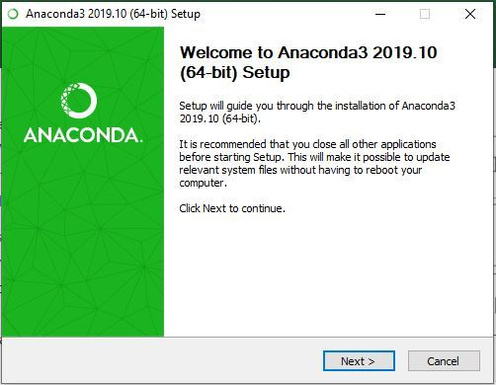
* **Getting through the License Agreement:**  
  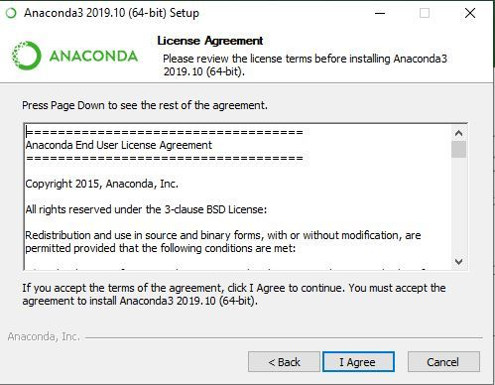
* **Select Installation Type:** Select **Just Me** if you want the software to be used by a single User  
  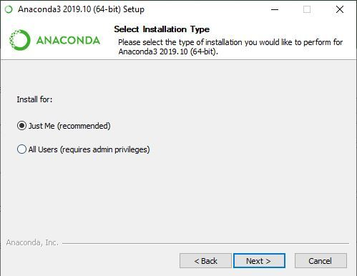
* **Choose Installation Location:**  
  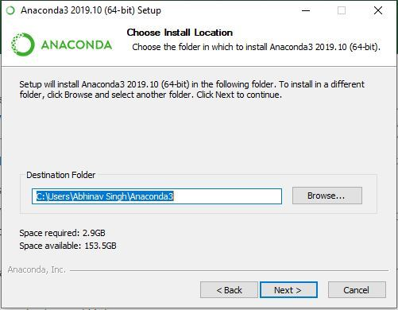
* **Advanced Installation Option:**  
  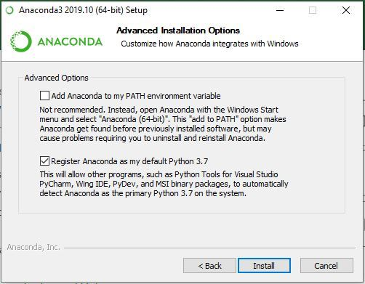
* **Getting through the Installation Process:**  
  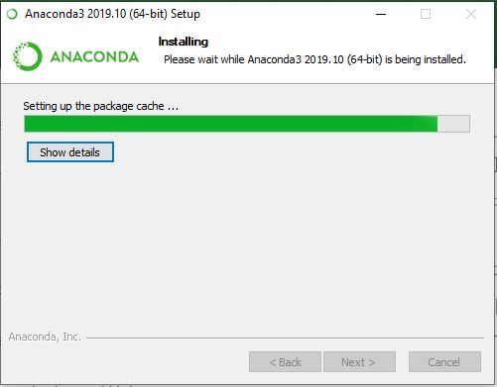
* **Recommendation to Install Pycharm:**  
  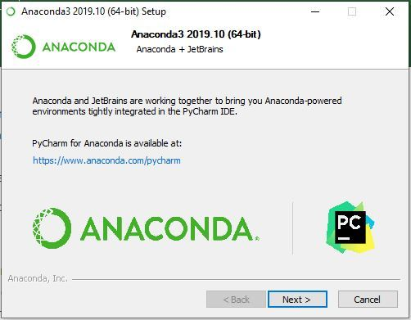
* **Finishing up the Installation:**  
  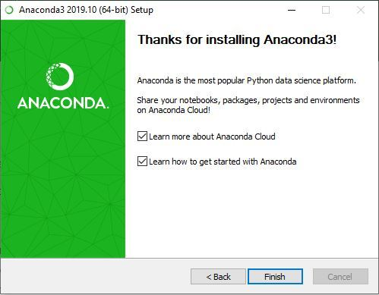

**Working with Anaconda:**

1. Navigate to the left pane.
2. Select the “Environments” selection.

1. On the next inner pane navigate to the bottom of the page and click on the Import.

1. Navigate to your .YAML file. And load it up in the Local Drive and name is “MoonTrek”
2. Click on the arrow located like the image below.  
   Graphical user interface, text, application, chat or text message

   Description automatically generated
3. With the Virtual Environment now set up, and a command prompt locate your MoonTrek directory.  
   A computer screen capture

   Description automatically generated with medium confidence
4. Unpack the .rar file of MoonTrekTelescopeV2-Final to another file.
5. %Directory% \MoonTrekTelescopeV2-Final\MoonTrekTelescopeV2\  
   Similar to the bottom prompt.  
   Text

   Description automatically generated
6. Then run the command “python manage.py runserver”
7. And navigate to the webpage “http://127.0.0.1:8000/”